are INVITED to an OPEN HOUSE Public Input Session
Tuesday (4/13/21) from 4:00pm to 7:00pm at the Hangar.
The town is in the discussion and planning phase for a proposed Recreation Center and Town Hall building, but we need YOUR input to make sure we build something the community can get a lot of use out of! Tonight will be a high level, idea collecting sort of meeting. You can look to see what general ideas, uses and types of spaces have been suggested so far. …
See more

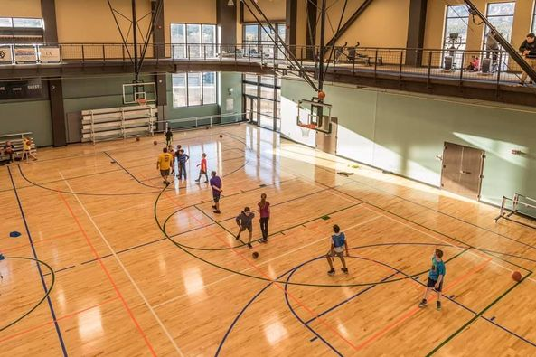

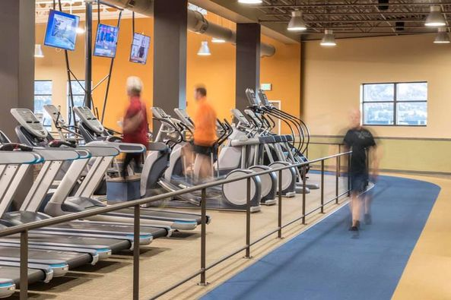

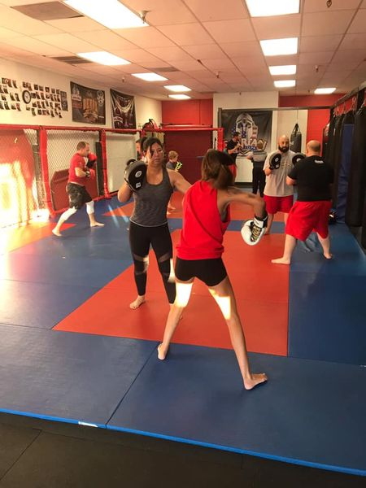

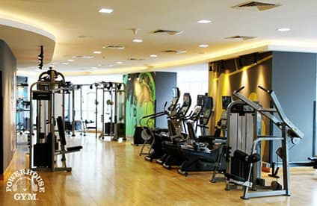

4646
29 Comments
Like
Comment
Send

29 Comments
All comments
﻿

Mitchell Groskopf

  - Like
  - Reply
  - 1y

Moseley Middleton
Archery Range would be an awesome low budget addition to the town.

3
  - Like
  - Reply
  - 1y

Tracy Guseman
How would this be paid for? Will there be an increase to property taxes? It would be nice to have a pool.

4
  - Like
  - Reply
  - 1y

Josef Sanchez
Tracy Guseman nobody like a bad attitude stop being greedy

    - Like
    - Reply
    - 1y

Tracy Guseman
Josef Sanchez you don’t even pay taxes goober! I’m all for a good complex just don’t wanna triple my taxes here...lol maybe it will have a wrestling mat!
      - Like
      - Reply
      - 1y

Josef Sanchez
Tracy Guseman

      - Like
      - Reply
      - 1y

Nancy Appel
Tracy Guseman yes a Pool! Would love it!

    - Like
    - Reply
    - 1y

Tracy Guseman
Nancy Appel that would be great for everyone! And a gym would be good too so we didn't have to drive all the way to town!

      - Like
      - Reply
      - 1y

Amber Lompe-Johnson
Erica Paej Ficken
  - Like
  - Reply
  - 1y

Dan Wolski
Kayla Wolosin
  - Like
  - Reply
  - 1y

Jammie King
Shane King
  - Like
  - Reply
  - 1y

Jake Bratton
Tori Boner Garrett Boner

  - Like
  - Reply
  - 1y

Garrett Boner
Jake Bratton biggest questions is is it affordable and how it’s getting paid for.
    - Like
    - Reply
    - 1y

Jake Bratton
Garrett Boner sounds like the money is already set aside but not sure
      - Like
      - Reply
      - 1y

Garrett Boner
Jake Bratton interesting
      - Like
      - Reply
      - 1y

Jake Bratton
Great idea. It would be a great place and healthy addition for both adults and kids! It takes 20 minutes for any of us out here to get to a gym. I don’t see how increased access to amenities that improve health and social interaction for kids could be a bad thing

5
  - Like
  - Reply
  - 1y

Annie Graham
Love this!!!
  - Like
  - Reply
  - 1y

Misty Wynia
Jason Wynia
  - Like
  - Reply
  - 1y

Gillian Owens
It would be nice, but is it affordable? Without taxes going up that is.

3
  - Like
  - Reply
  - 1y

Tim Ficken
Gillian Owens I believe it's already been budgeted and the money is set aside.

2
    - Like
    - Reply
    - 1y

Jessica Moss
Christina Corson
  - Like
  - Reply
  - 1y

Bryan Iglehart
Are you thinking of branding the building like the True fun palace?
  - Like
  - Reply
  - 1y

Toni Stephenson
Brandon Stephenson
  - Like
  - Reply
  - 1y

Rhonda Weinman Strange
If I remember correctly there was already a budget set for townhall…. a completely over the top doesn't give anything back to the community town hall..... I know I for one am excited to show up and get more information We need something like this in …
See more


GIPHY

  - Like
  - Reply
  - 1y
  - Edited

Jenifer Hopkins
A climbing wall
  - Like
  - Reply
  - 1y

Faye Rankin Hall
I am at work and cannot go to meeting, but if this increases taxes, I am opposed. Sorry.

2
  - Like
  - Reply
  - 1y

Mellissa Woodraska-Olson
This is awesome!
  - Like
  - Reply
  - 1y

Pam Barnhill
I am opposed to higher taxes or any type of fees to pay for something that is 15 minutes from us. Sorry!

  - Like
  - Reply
  - 1y

Rhonda Weinman Strange
All those opposed to paying higher taxes I sure hope your helping the town council with the dissolving of Wardwell.......As a Bar Nunn resident we are being charged more. Get nothing in return except the amazing service the offer and for them to tell u…
See more

2
  - Like
  - Reply
  - 1y
Active

Write a comment…

